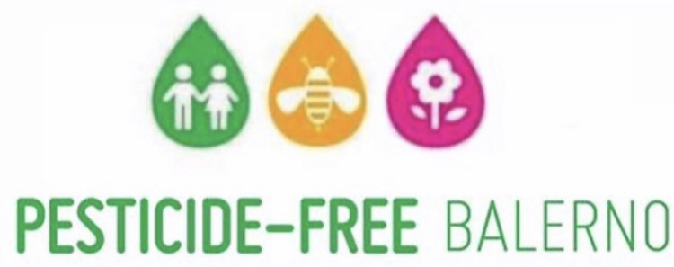

Dear

It has come to my attention, that our estate  still uses harmful pesticides for weed control.

As a resident of  I wanted to raise awareness about the benefits of **using safe alternatives rather than pesticides**for weed control.

Personally I have already requested that outside my own home be left untreated with no further use of chemicals to treat weeds on the pavement. I am taking full responsibility for the small strip of weeds in front of my house by manually weeding.

I fully understand that tidiness and maintenance of is important to residents, however manual weeding methods or safe alternatives free from harmful chemicals are also entirely effective and are already being used successfully around the U.K.

Safety is the no.1 priority for many of our residents especially some of our most vulnerable.

Encouragement of environmentally friendly methods to protect our health and our natural environment is the way forward.

Most councils use Glyphosate based weed killers, although many are desperately looking to move away from this chemical considering its recent controversy.

Glyphosate is a notorious chemical under worldwide investigation for its harmful effects on human and animal health, including Cancer. It is also under investigation for its long term negative effects on our environment.

Many towns and villages have banned and replaced this type of weed control with safe alternatives and Pesticide-Free Balerno is one of them! This initiative worked alongside The City of Edinburgh Council to end the use of Glyphosate and other harmful chemicals for weed removal in Balerno 2020.

Unnecessary pesticide use contaminates the air, soil and water.

When using chemical weed killers, you are relying on having 24hrs rain and wind free weather for application. Rain can lead to the wrong plants being targeted, as well as run-off issues into other areas that you want to avoid. Links have been made with pesticides to declines in bee pollinators, beneficial insects, birds, aquatic animals and non-target plants.

**The World Health Organization** released a statement in 2015 stating that glyphosate was**“probably carcinogenic to humans.”**

We are starting to collect signatures to ask our to stop the use of pesticides and switch to safe alternatives to manage our

Here are some educational links to read more:

Continued/…

**Page 2.**

<https://issuu.com/pan-uk/docs/a_guide_to_lobbying_against_glyphos?e=28041656/59432891>

<https://cropwatch.unl.edu/multiple-herbicide-resistant-weeds-and-challenges-ahead>

<https://www.weedingtech.com/alternatives-to-glyphosate/>

<https://www.baumhedlundlaw.com/toxic-tort-law/monsanto-roundup-lawsuit/where-is-glyphosate-banned-/>

<https://www.pesticidefreebalerno.com/>

Please join me and many others in   in being precautionary and asking the council for an end to the use of harmful chemicals where we live, work and play. Please ask for safe alternatives to be used instead-protecting health and the environment by signing the petition below.

Thank you